WDFT Final Project

**Project Title:** *Name of your project*

**Author:** *Full Name*

**Cohort:** *Your cohort including year*

***NOTE: REPLACE ALL BLUE PARTS OF THIS DOCUMENT WITH INFORMATION RELEVANT TO YOUR PROJECT***

## Project Overview

### 1.1 Description

*High level description of the project in plain English in a couple of sentences. This is like the* [*Elevator pitch*](https://en.wikipedia.org/wiki/Elevator_pitch) *of your project.*

### 1.2 Problem

*Specifics of the problem your project solves, background information around the problem, pain points, etc.*

### 1.3 User Profile

*Who is the end user? How will they use your application? How does the application help them? Are there any special considerations that your design must take into consideration for the end user?*

### 1.4 Requirements: Use Cases and Features

*A list of the functionality that your project will implement to solve the above problem. Can be written as user stories (*[*examples of user stories*](https://www.mountaingoatsoftware.com/agile/user-stories)*) or descriptions of functionality with related details. Do not describe how these features are implemented, only WHAT needs to be implemented.*

### 1.5 Tech Stack and APIs

* *Technologies that will be used in solution*
* *Any libraries that will be used to save time or provide more functionality (make sure you have researched and understand how to use the libraries and any potential limitations.*
* *APIs/Web sites that will be required in the solution for data*

## 2. Client-Side Implementation

### Site Map

*List of pages/screens that your project will implement with brief descriptions. You can use* [*draw.io*](https://www.draw.io/) *to make technical diagrams. e.g.)*

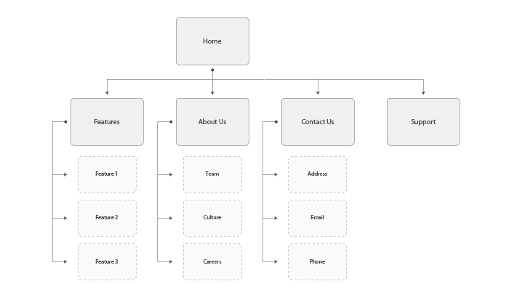

*In list format:*

* *Home*
* *Features*
  + *Feature 1*
  + *Feature 2*
  + *Feature 3*
* *About Us*
  + *Team*
  + *Culture*
  + *Careers*
* *Contact Us*
  + *Address*
  + *Email*
  + *Phone*
* *Support*

### Screen Details

*Mockups and/or descriptions of input/output or state that the screens will need. You can use online tools like* [*Balsamiq*](https://balsamiq.com/index.html)*, or pictures of hand drawn mockups, whichever is easiest to identify key ideas of the user interface.*

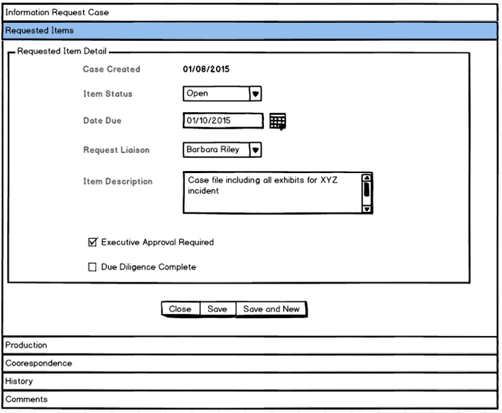

## 3. Server-Side Implementation

### 3.1 End-Point Descriptions

*A list of endpoints your server will implement, HTTP methods for the end points, and any parameters that the endpoint will accept to fulfill the request. e.g.:*

|  |  |
| --- | --- |
| **End-point** | **Response Format** |
| *HTTP GET - /todos* | *{ todos : [ { text : ‘STRING’, done : TRUE/FALSE, ID : NUMBER } … ] }* |
|  |  |

### 3.2 External APIs that will be consumed

*If your project uses APIs (e.g. twitter, google maps, etc), a list of the APIs that will be used, how the API will be used. API should have been thoroughly investigated to confirm it can do what you think it can do.*

### 3.3 Database Structure

*If your project includes a database, the structure should be described including tables with fields (for relational dbs), or documents and attributes (for non-relational dbs). If your table does not include a database, describe any persistent storage that you will be using (e.g. flat-files, directories). If desired, diagrams can be drawn using tools such as* [*draw.io*](https://www.draw.io/)

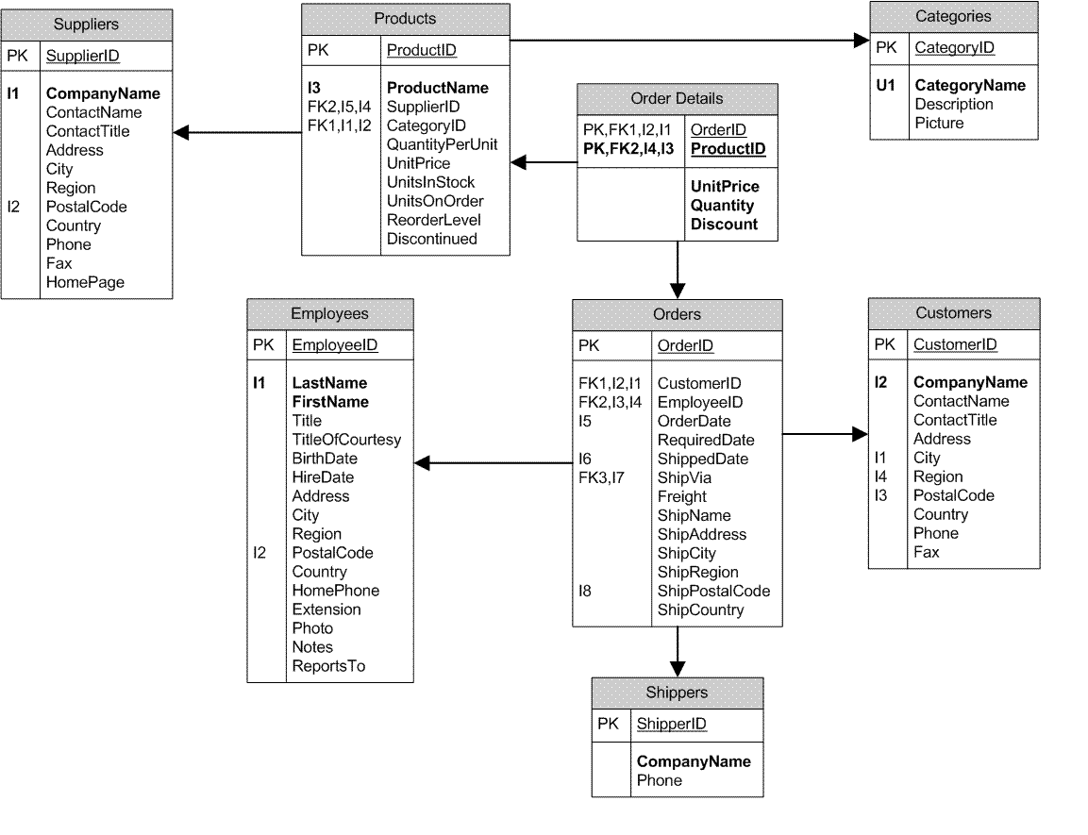

### 3.4 Authentication/Authorization and Security

*Description of any user profile/login functionality that you need, as well as any authentication/authorization that your project will use.*

## 4. Project Roadmap

### Phase 1

*A subset of the features that you have listed in Section 1.4.* ***This is what you are committing to have completed for demo day.******Your project will be marked based on what you commit to in Phase 1.*** *Think about what you can reasonably complete within 8 - 10 working days, and what will demonstrate your skills in an interesting way to the audience on Demo Day. Note that the more clearly you have planned out your project in the preceding sections, the easier it is to focus on implementing your project step by step.*

*You must scope out Phase 1 as accurately as you can as a 1 week “mini-sprint”. Assuming that you begin your project on Tuesday of Week 9, and everything is due on Wednesday of Week 10, that gives 7 in-class days to work on your final project. The more detailed you can be, the more you can be assured that you can complete your plans. Also note that you may encounter “problems”, consider having 1 day of buffer time to account for unexpected problems. e.g.)*

|  |  |
| --- | --- |
| **Day** | **Goal** |
| *1 (Wed)* | *Create database and design models* |
| *2 (Thurs)* | *Build server boilerplate and hook up to database* |
| *3 (Friday)* | *Define all Endpoints in express, connect endpoints to any external web api* |
| *4 (Mon)* | *Implement functionality of endpoints - create JSON response and verify endpoint responses* |
| *5 (Tues)* | *Build React App overall structure and high-level components* |
| *6 (Wed)* | *Connect smart components to end-point APIs* |
| *7 (Thurs)* | *Test/debug end-to-end functionality of app* |
| *8 (Fri)* | *Implement CSS/Styling* |
| *9 (Mon)* | *Code Clean up, last minute testing/debugging* |
| *10 (Tues)* | *DEPLOYMENT* |
| *11 (Wed)* | *DEMO DAY* |

### Phase 2

*This is what features you may complete if you have extra time, or what you would work on next after Phase 1 is complete.*

### Phase 3

*This is nice to have features or future enhancements that are more complex, or take the project to a more completed, production-ready state.*

## 5. Demo Day Placard Information

Please fill out the attached Google Form to complete your placard information required for Demo Day.